Analysis Artifacts for Use Case 04  
Report Extraction

**Table Of Contents**

**1.** **Build ERD** **2**

**2. Robustness Diagram** **3**

**3. Class Diagram** **4**

**4. Sequence Diagram** **5**

**5. Communication Diagram** **6**

**6. State Diagra****m 7**

**7. Data Flow Diagram** **8**

# **Build ERD** ~~: Created by Tejaswi Dasyam~~

# 

**[diagram below was deleted]**

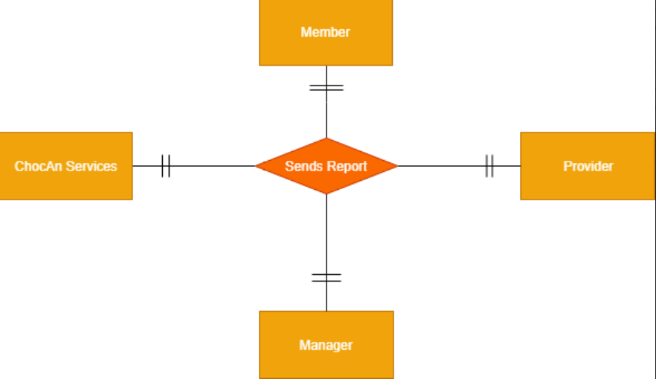

# **2. Robustness Diagram** ~~: Created By Kopal Shinde~~

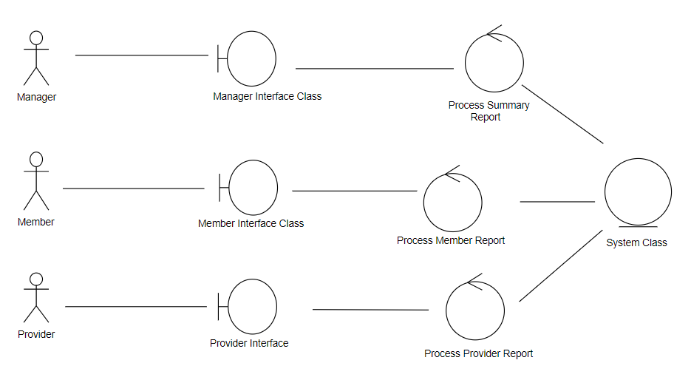

# **3. Class Diagram** ~~: Created By Khushmeet~~

**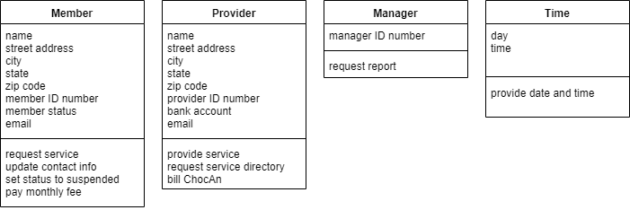  
  
  
  
  
  
[diagram below was deleted]**

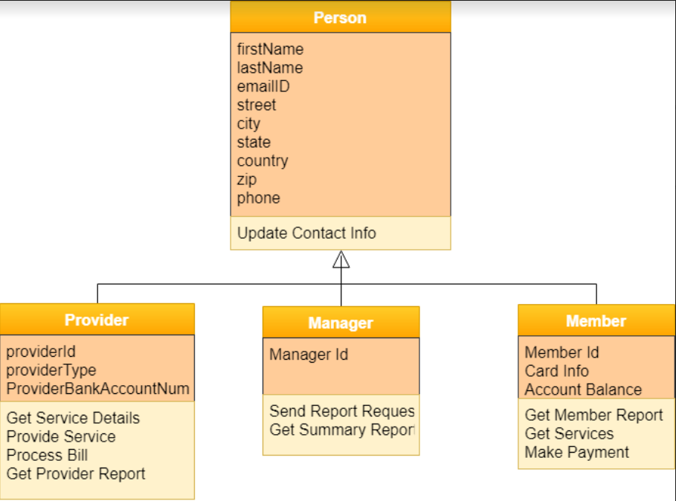

# **4. Sequence Diagram** ~~: Created By Vaishali Jain~~

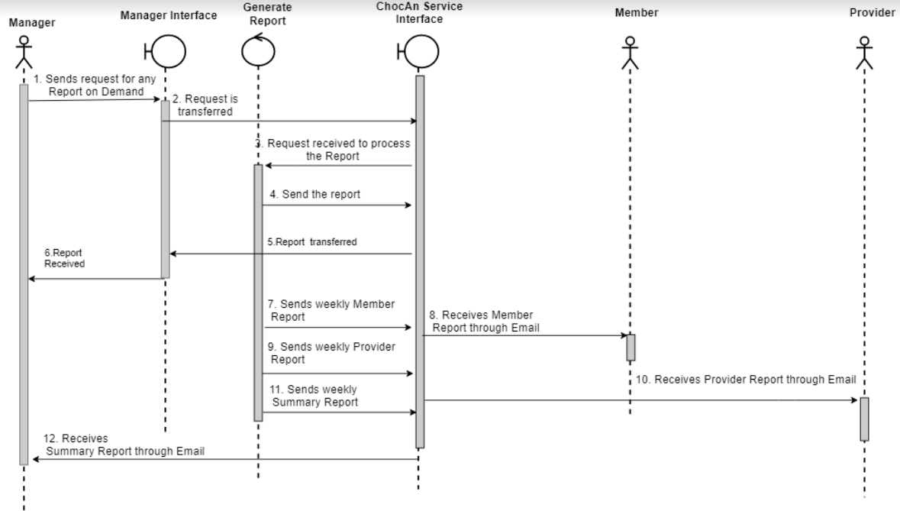

# **5. Communication Diagram** ~~: Created By Kopal Shinde~~

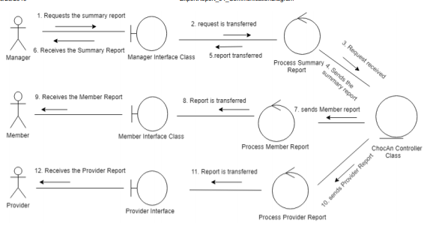

# **6. State Diagram** ~~: Created By Kopal Shinde~~

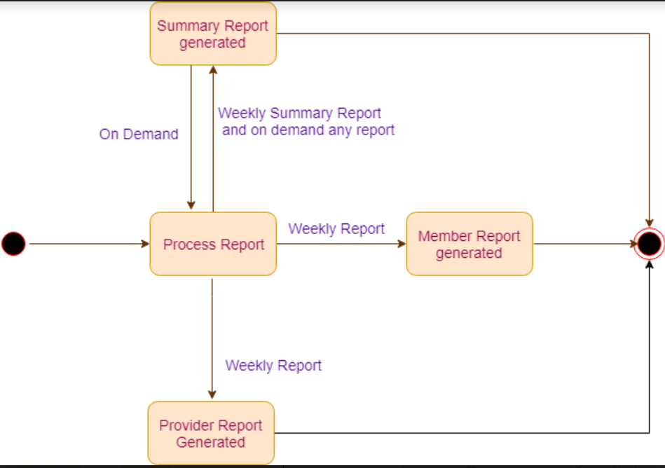

# **7. Data Flow Diagrams** ~~: Created By Mohana~~

**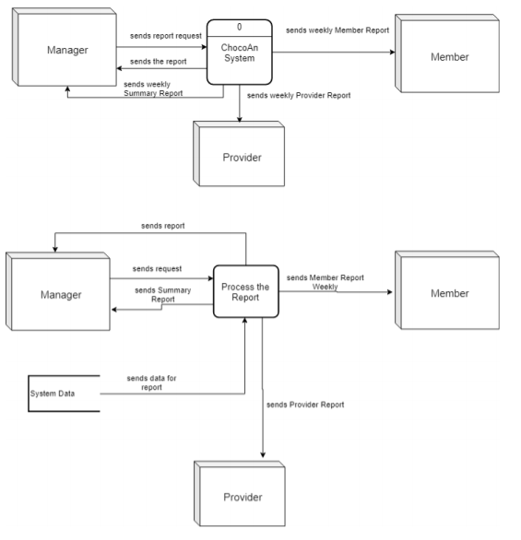  
  
  
[diagram below was revised]**

